Polar Bear Ongoings – taken from the Polar Bear Specialist Group website
Note: The Polar Bear Specialist Group is group of 25 scientists who meet every 3-5 years under the guidelines of the International Union for Conservation of Nature’s Species Survival Commission. They share data publically about the status of polar bears.
Polar bears are not evenly distributed throughout the Arctic, nor do they comprise a single nomadic cosmopolitan population, but rather occur in 19 relatively discrete subpopulations. There is however an uncertainty about the discreteness of the less studied subpopulations, particularly in the Russian Arctic and neighboring areas, due to very restricted data on live capture and tagging. The total number of polar bears worldwide is estimated to be 20,000 - 25,000.
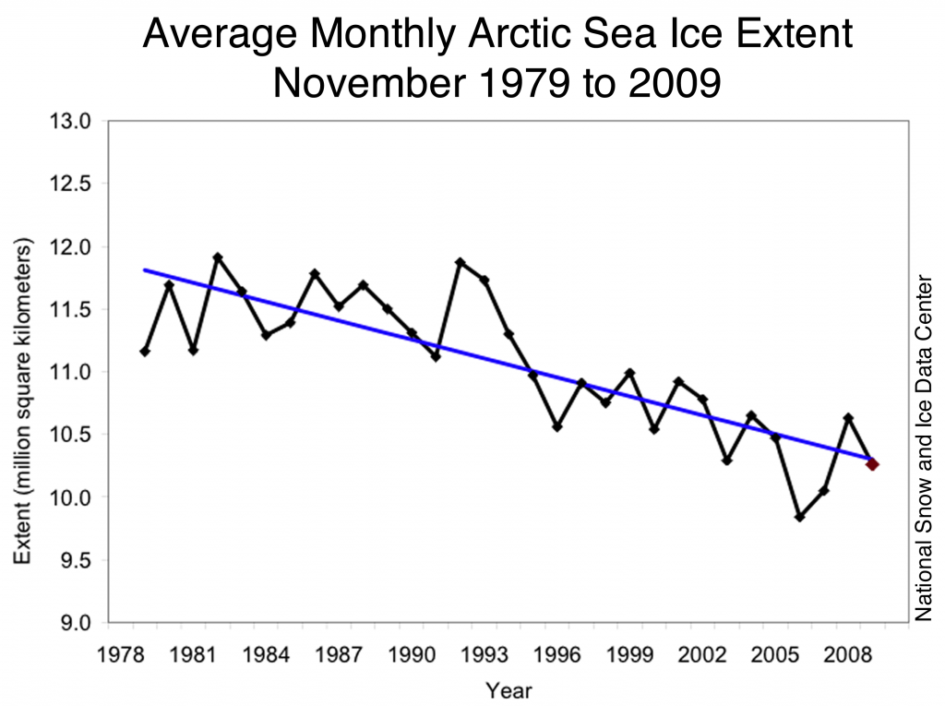
Polar bears and their prey have evolved to living in the extreme conditions of the Arctic. Polar bears and seals are dependent on sea-ice for foraging, resting, and reproduction. Today, polar bear populations are facing threats previously unprecedented during recorded history in the Arctic. Recent climate change scenarios based upon modeling of climate trend data predict that the Arctic region will experience major changes in the upcoming decades.
Polar bears are not evenly distributed throughout the Arctic. They do not make up a single population, but rather occur in 19 relatively discrete subpopulations. Currently, eight populations are declining, three are stable, and one is increasing in size. We don’t know enough about the rest of the populations to know whether their populations are increasing or decreasing.
An Example from Hudson Bay
In Western Hudson Bay researchers have collected demographic information on polar bears since 1981, where the sea ice breakup has been occurring earlier. The earlier breakup has been related to the poorer condition of polar bears and there is a correlation between the earlier breakup and a pattern of warming air temperatures during the spring between 1950 and 1990. It appears that earlier breakup caused by warmer temperatures has resulted in declines in physical and reproductive parameters of polar bears in this area. This is the only study to date to demonstrate the effects of changed environment resulting from climate changes, and a corresponding effect on polar bears. Climate change is not uniform in all areas of the Arctic, however. Since Hudson Bay is located at the southern most extent of the range of polar bears, findings here may be a forewarning of changes to come in future years for other areas of the Arctic.

What else affects polar bears?
Environmental contaminants in the form of persistent organic pollutants pose an additional area of increased concern for polar bears. Polar bears, as a top predator who accumulate harmful compounds, are a perfect candidate for studies in evaluating trends. We now know that polar bears inhabiting certain areas of the Arctic exhibit high levels of organochlorines, particularly PCB's (poly chlorinated biphenyls) while populations inhabiting other areas have lower levels. Laboratory experiments involving elevated levels of organochlorines have been associated with a range of effects including neurological, reproductive, and immunological changes.
Current Polar Bear Population Status
Data in the table below come from a number of studies. Some of the studies used mark-recapture techniques, and then estimated the population sizes, while others used aerial surveys. Some studies also looked at the body conditions of the bears that they surveyed, and were thus able to say something about the health of the animals. For example, the population of Western Hudson Bay has been declining, with fewer cubs surviving, and the body condition of adults deteriorating, based on a mark-recapture study and information about bears killed by Inuit hunters. Researchers in Western Hudson Bay found that in years when the sea ice melted earlier in the spring, the survival of cubs, young, and old bears was poor.
Population | Population Size | Current Trend
Arctic Basin | Unknown | Unknown
Baffin Bay | 2,074 | Declining
Barents Sea | 2,650 | Unknown
Chukchi Sea | Unknown | Declining
Davis Strait | 2,142 | Declining
East Greenland | Unknown | Unknown
Foxe Basin | 2,197 | Unknown
Gulf of Boothia | 1,592 | Stable
Kane Basin | 164 | Declining
Kara Sea | Unknown | Unknown
Lancaster Sound | 2,541 | Declining
Laptev Sea | 800-1,200 | Unknown
M’Clintock Channel | 284 | Increasing
Northern Beaufort Sea | 1,202 | Stable
Norwegian Bay | 190 | Declining
Southern Beaufort Sea | 1,526 | Declining
Southern Hudson Bay | 900-1,000 | Stable
Viscount Melville Sound | 161 | Unknown
Western Hudson Bay | 935 | Declining

Source: Adapted from Polar Bear Specialist Group, IUCN Species Survival Commission website

